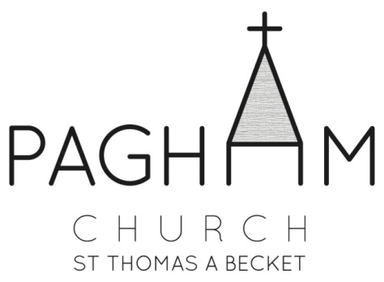
PAGHAM PARISH CHURCH

St Thomas à Becket Church,

Church Lane, Pagham, PO21 4NU

ART EXHIBITION IN THE CHURCH 2018

Saturday 5th – Monday 7th May

The annual Art Exhibition of the work of local artists in Pagham Parish Church will this year be held from Saturday 5th May 2018 to Monday 7th May 2018 inclusive. The exhibition will be open between 10 am – 5 pm on Saturday 5th May and Monday 7th May, and 12 noon – 5 pm on Sunday 6th May.

You are cordially invited to submit a maximum of 5 pictures for the exhibition.
Each picture should be securely framed, with a label on both the face and the back, giving your name, the title or description of the work, the medium used and the price. We are also willing to accept box canvasses.

This year we are again welcoming unframed pieces of work (maximum of 10). These will not be hung, but shown in a Folio Stand. Please ensure that works are clearly labelled and protected in plastic.

There will be a hanging fee of £1.00 per framed picture or box canvas and 50p per unframed piece of work, and should any of your pictures be sold at the exhibition there will be a commission charge of 15%.

Should you wish to exhibit any pictures please complete the attached form and return it to Trudi Kearsley, 37 West Drive, Aldwick, Bognor Regis, PO21 4LY (Tel: 01243 263597 or 07703597353), or at Church, before Sunday 29th April, accompanied by the appropriate hanging fee.
If a picture is not for sale please enter NFS in the price required column of the entry form. Please make cheques payable to Pagham Parochial Church Council (Pagham PCC).

If you are prepared to assist with stewarding during the exhibition, please indicate this on your entry form.

All pictures for exhibition should be brought to the Church on Thursday 3rd May 2018 between 6.00 pm and 8.00 pm, when they will be hung under the direction of the committee. The pictures will remain on exhibition until 5.00 pm on Monday 7th May 2018 and should be collected on Wednesday 9th May 2018, between 6.00 pm and 8.00 pm in the evening. If you have any difficulties with delivering or collecting the exhibits within the stipulated times, please contact Trudi Kearsley (01243 263597/07703597353) for assistance.

The committee will take all reasonable precautions for the safety of exhibits but accept no liability for loss or damage thereto.

Timetable

Thursday 3rd May 2018 6.00 pm to 8.00 pm Deliver pictures to Church

Saturday 5th May 2018 10.00 am to 5.00 pm Exhibition open

Sunday 6th May 2018 12.00 noon to 5.00 pm Exhibition open

Monday 7th May 2018 10.00 pm to 5.00 pm Exhibition open

Wednesday 9th May 2018 6.00 pm to 8.00 pm Collect Pictures from Church

PLEASE NOTE THAT TIMES FOR COLLECTION ON WEDNESDAY 9th MAY ARE 6.00 pm to 8.00 pm (Service taking place in Church until 5.50 pm)

LIGHT LUNCHES, HOME MADE CAKES, TEA AND COFFEE - AVAILABLE FOR PURCHASE – DAILY

I enclose £1.00 per framed picture or box canvas hanging fee (50p for unframed exhibits). Cheques payable to Pagham Parochial Church Council.

I understand that should I wish to sell any of my pictures there will be a commission of 15% of the selling price payable to Pagham Parochial Church Council.

I understand that the committee take all reasonable precautions for the safety of pictures exhibited but accept no liability for loss or damage thereto.

Signed ……………………………………………..

Stewarding

Please delete as necessary

I will/will not be able to help with stewarding.

Please tick where available.
SATURDAY 5TH MAY | SUNDAY 6TH MAY | MONDAY 7TH MAY
a.m. 10.00 - 12.00 | ********************* | a.m. 10.00 – 12.00
p.m. 12.00 - 2.00 | p.m. 12.00 - 2.00 | p.m. 12.00 - 2.00
p.m. 2.00 - 3.30 | p.m. 2.00 - 3.30 | p.m. 2.00 – 3.30
p.m. 3.30 - 5.00 | p.m. 3.30 – 5.00 | p.m. 3.30 – 5.00

Parish Church of St Thomas à Becket, Pagham

Art Exhibition Entry Form 2018
Saturday 5th May to Monday 7th May
Pagham Parish Church

Name: ……………………………………………………

Address: …………………………………………………

……………………………………………………………

Phone: …………………………………………

e-mail: …………………………………………

I wish to enter the following pictures in the Exhibition:

 | Title/Description | Medium | Size | Price

Parish Church of St Thomas à Becket, Pagham

Art Exhibition Entry Form 2018

Saturday 5th May to Monday 7th May
Pagham Parish Church

Name ………………………………………………………………………………
Address ………………………………………………………………………………
………………………………………………………………………………
Phone ………………………………………………………………………………
e-mail address: ………………………………………………………………………

I wish to enter the following unframed pictures in the Exhibition:

 | Title/Description | Medium | Size | Price

